BIOLOGY FINAL EXAM REVIEW-FALL 2017
The final exam is a cumulative exam, covering information from the entire semester. It is composed of 50 multiple-choice questions. You will have 2 hours to complete the exam, so use your time accordingly. REMEMBER- IT IS 25% OF YOUR SEMESTER GRADE!

Unit 1: The Nature of Science
- What is Biology?
- Explain the components of a good hypothesis
- Describe the following components of an experiment:
  - Independent Variable
  - Dependent Variable
  - Constants
  - Control Group
  - Experimental Group

Unit 2: Ecology

- Define and be able to explain how the following terms/concepts relate to the unit:
  - Ecology d. Predation
  - Mutualism e. Commensalism
  - Parasitism

- List the characteristics of living things.
- What is homeostasis?
- Write the levels of ecological organization on Earth from simplest to most complex.
- What is the original source of energy for almost all the energy in most ecosystems?
- Only 10 percent of the energy stored in an organism can be passed on to the next trophic level. What happens to the remaining 90% of the energy?

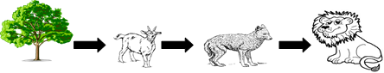

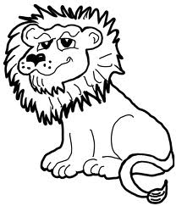
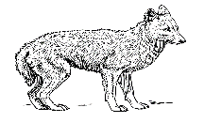
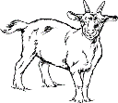
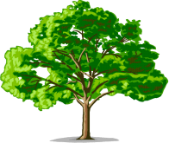
- Label each of the levels of the food chain above as a producer or type of consumer.
- How many trophic levels are represented in the food chain above? _______
- Which trophic level has the most available energy?

Unit 3: Biochemistry
- Describe a monomer vs. polymer.
- List the functions of carbohydrates.
- What is the monomer of a carbohydrate?
- List the functions of lipids.
- List examples of lipids
- What are the 2 parts of the monomer that makes up a lipid
- List the functions of proteins.
- What is the monomer of a protein?
- List the functions of nucleic acids.
- Name the monomer of a nucleic acid and the 3 parts that make up the monomer.
- What type of biomolecule is an enzyme?
- Enzymes are catalysts. The primary function of an enzyme is-
- What happens to an enzyme that has been denatured?
- What does it mean for an enzyme to be substrate specific?
- What are the factors that can affect enzyme activity?

Unit 4: Cell Structure and Function
- List several differences between organelles found in animal and plant cells.
- Describe the function of the following organelles:
  - Rough ER e. Chloroplasts
  - Ribosomes f. Cell membrane
  - Nucleus g. Cell wall
  - Mitochondria
- Describe the differences between prokaryotic and eukaryotic cells.
- Compare/contrast cell wall and cell membrane structure and function
- What are the channels and pumps in the cell membrane made of?
- Describe what happens in cellular respiration. Include the reactants, products and the organelle that carries out cellular respiration.
Define the following and know how they relate to the unit:

- Osmosis
- Diffusion
- Active Transport
- Isotonic Solution
- Hypertonic Solution
- Hypotonic Solution

Unit 5: DNA and Protein Synthesis
- Draw a nucleotide and label each component
- Describe the steps of DNA Replication. Make sure to include when, where and how DNA replication occurs.
- What is the role of DNA polymerase?
- Compare and contrast DNA and RNA.
- Describe the process of transcription. Make sure to include where, why and how transcription occurs.
- Describe the process of translation. Make sure to include where, why and how translation occurs.
- Be able to recognize diagrams that represent transcription and translation.
- During translation, what determines which amino acid is added to the growing polypeptide?
- How much adenine, guanine, and cytosine are present if a DNA strand contains 20% thymine?

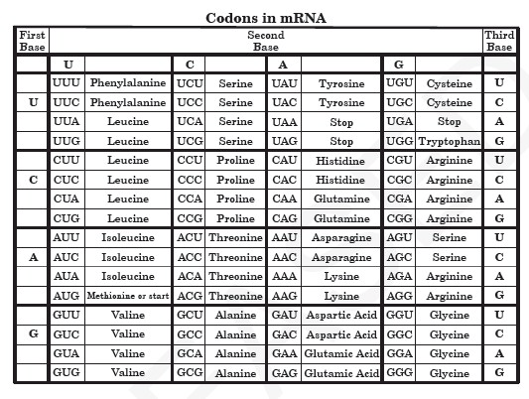
*Use the table above to answer the following questions:
Example DNA strand= TACCGGCATCGT
- Write the complementary mRNA strand from the DNA sequence above.
- Write the amino acids that will be translated from the DNA strand.

