Name:________________________________________ Pg1
Characteristics of Life

Most people feel confident that they could identify a living thing from a nonliving thing, but sometimes it’s not so easy. Scientists have argued for centuries over the basic characteristics that separate life from non-life. Some of these arguments are still unresolved. Despite these arguments, there do seem to be some generally accepted characteristics common to all living things. Anything that possesses all these characteristics of life is known as an organism.

The scientific term for a living thing is an ___________________________________________.

1. CONTAIN ONE OR MORE CELLS

Scientists know that all living things are organized. The smallest unit of organization of a living thing is the cell. A cell is a collection of living matter enclosed by a barrier that separates it from its surroundings. Cells can perform all the functions we associate with life.
Cells are organized and contain specialized parts that perform particular functions. Cells are very different from each other. A single cell by itself can form an entire living organism. Organisms consisting of only a single cell are called unicellular. But, most of the organisms you are familiar with, such as dogs and trees, are multicellular. Multicellular organisms contain hundreds, thousands, even trillions of cells or more. Whether it is unicellular or multicellular, all structures and functions of an organism come together to form an orderly living system.
Cells are not found in nonliving matter. Structures that contain dead cells or pieces of cells are considered dead. For example, wood cut from a tree is made up largely of cell walls. The cells are no longer functional.

- What is the difference between unicellular and multicellular organisms?
______________________________________________________________________________________
______________________________________________________________________________________
Examine these 2 organisms. Which one is unicellular? Multicellular? Label each.
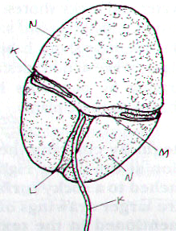
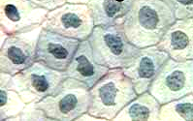
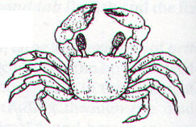

POND ORGANISM (under the microscope)
(under a microscope)

2. REPRODUCE

Perhaps the most obvious of all the characteristics of life is reproduction, the production of offspring. Organisms don’t live forever. For life to continue, organisms must replace themselves. Reproduction is not essential for the survival of an individual organism. However, it is essential for the continuation of an organism’s species. A species is a group of similar-looking organisms that can interbreed and produce fertile offspring. If individuals in a species never reproduced, it would mean an end to that species’ existence on Earth.

- Define reproduction. _______________________________________________________________
______________________________________________________________________________________
Pg2

There are two basic kinds of reproduction: sexual and asexual. Sexual reproduction requires that two cells (sperm and egg) unite to produce the first cell of the new organism. Organisms reproducing sexually do not always have “sex!” In many cases sperm and egg are released into the water where they meet. Most familiar organisms - from maple trees to birds and bees - reproduce sexually. In asexual reproduction, a single organism can reproduce without the aid of another. Sometimes these organisms can just divide themselves in two!

- Name and define the two basic kinds of reproduction:
______________________________________________________________________________________
______________________________________________________________________________________
- Identify which organisms are reproducing sexually and which are reproducing asexually.

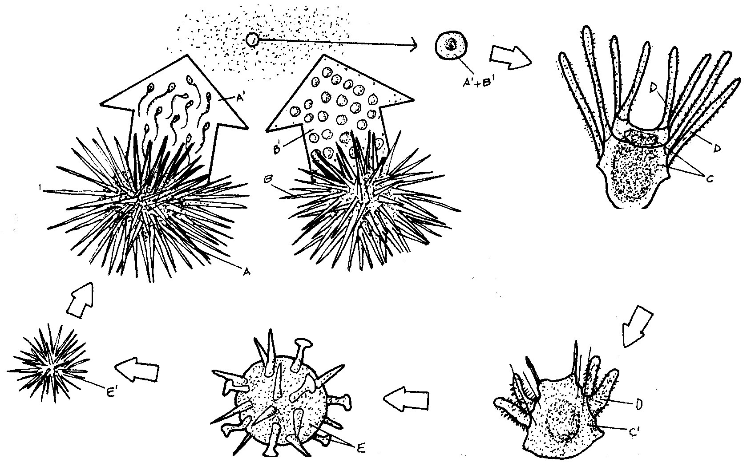
BACTERIA SEA URCHIN

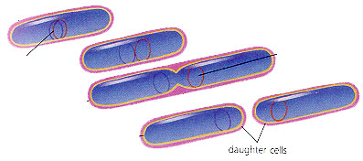

3. GROW AND DEVELOP

Adults don’t always look like the babies of a species. All organisms begin their lives as single cells. Over time, these organisms grow and take on the characteristics of their species. Growth results in an increase in the amount of living material and the formation of new structures.
All organisms grow, and different parts of organisms may grow at different rates. Organisms made up of only one cell may change little during their lives, but they do grow. On the other hand, organisms made up of numerous cells go through many changes during their lifetimes. Think about some of the structural changes your body has already undergone in your short life. All of the changes that take place during the life of an organism are known as its development.

- What is the difference between growth and development?
____________________________________________________________________________________________________________

____________________________________________________________________________________________________________

__________________________________________________________________________________________________

A snowball grows when you roll it over fresh snow! Why isn’t it a living thing? The growth of the snowball is not internal. Someone has to roll the snowball. It won’t grow bigger by just sitting there and it certainly cannot change liquid water or solid ice into new snow from which it can grow larger. This is one of the differences between growth of a living thing and growth of a nonliving thing.

Pg3
4. OBTAIN AND USE ENERGY

Energy is the ability to make things change. Energy is important because it powers life processes. It provides organisms with the ability to maintain balance, grow, reproduce, and carry out other life functions. Some organisms obtain energy from the foods they eat or, in the case of plants and several other types of organisms, the foods that they produce. Organisms that get energy from the food they eat are called heterotrophs. Organisms that use energy from the sun to make their own food (which they then use for energy) are called autotrophs.
As you’ll learn, energy doesn’t just flow through individual organisms; it also flows through communities of organisms, or ecosystems, and determines how organisms interact with each other and the environment.

- Define energy: ____________________________________________________________________________
- Why is energy important to a living organism? ________________________________________________
____________________________________________________________________________________________

5. RESPOND TO THE ENVIRONMENT / MAINTAIN HOMEOSTASIS
Living things live in a constant connection with the environment, which includes the air, water, weather, temperature, any organisms in the area, and many other factors. These external environmental factors can change thereby causing a response from living things. Organisms need to respond to the changes in order to stay alive and healthy. For example, if you go outside on a bright summer day, the sun may cause you to squint. Just as you are constantly sensing and responding to changes in your environment, so are all other organisms. For example, a specialized leaf of the Venus' flytrap senses the light footsteps of a soon-to-be-digested green bottle fly. The plant responded to this environmental stimulus by rapidly folding the leaf together.
An organism must respond to changes in the internal environment as well. Internal conditions include the level of water, nutrients and minerals inside the body. It also refers to body temperature and hormone levels. Adjustments to internal changes help organisms maintain a stable internal environment. The regulation of an organism’s internal environment to maintain conditions suitable for life is called homeostasis. Or you can just think of it as keeping everything in BALANCE! For example, you have a "thermostat" in your brain that reacts whenever your body temperature varies slightly from 37°C (about 98.6°F). If this internal thermostat detects a slight rise in your body temperature on a hot day, your brain signals your skin to produce sweat. Sweating helps cool your body.
The ability of mammals and birds to regulate body temperature is just one example of homeostasis. Mechanisms of homeostasis enable organisms to regulate their internal environment, despite changes in their external environment.
- If light is applied to a human eye, how does it respond?
______________________________________________________________________________________
______________________________________________________________________________________
- Describe homeostasis, in your own words.
______________________________________________________________________________________
______________________________________________________________________________________
Pg4
6. CONTAIN GENETIC INFORMATION
All living organisms contain genetic material in the form of DNA that carries information about an organism. DNA stands for deoxyribonucleic (dee AHK see RY bo new KLEY ik) acid. The genetic material present in our cells is like a blueprint to a house. DNA is what provides the instructions to make you who you are. It dictates how tall you are, your hair, eye, and skin color. Copies of DNA are passed from parent to offspring during reproduction. This is called heredity.

- What would be the outcome of two organisms sharing the exact same DNA? Can you think of any examples of this happening?
______________________________________________________________________________________________________________________________________________________________________________________
- Would DNA be found in abiotic objects such as rocks? Why or why not? _____________________ ___________________________________________________________________________________________
- Would DNA be found in dead organisms? Why or why not? __________________________________
___________________________________________________________________________________________

7. EVOLVE AND ADAPT
Evolution is the change that occurs in organisms over time. An inherited trait that gives an advantage to individual organisms and is passed on to future generations is an adaptation. Over time, the makeup of a population changes because more individuals have the adaptation. Evolutionary adaptations are changes in a species that occur over many generations due to environmental pressures, not through choices made by organisms.
For instance, consider the thorn bug (shown below). This particular insect has developed physical traits that make it look very similar to a thorn on the stem of a plant, allowing it to survive attacks from predators and ultimately reproduce.

a) True or False: Evolution causes individuals of a species to change. If true, explain why. If false, change the sentence so it becomes true and explain why you made the change.
__________________________________________________________________________________________________
__________________________________________________________________________________________________
Thorn Bug
Plant Stem

