C

**A**

**J**

**I**

**H**

**G**

**F**

**E**

**D**

**B**

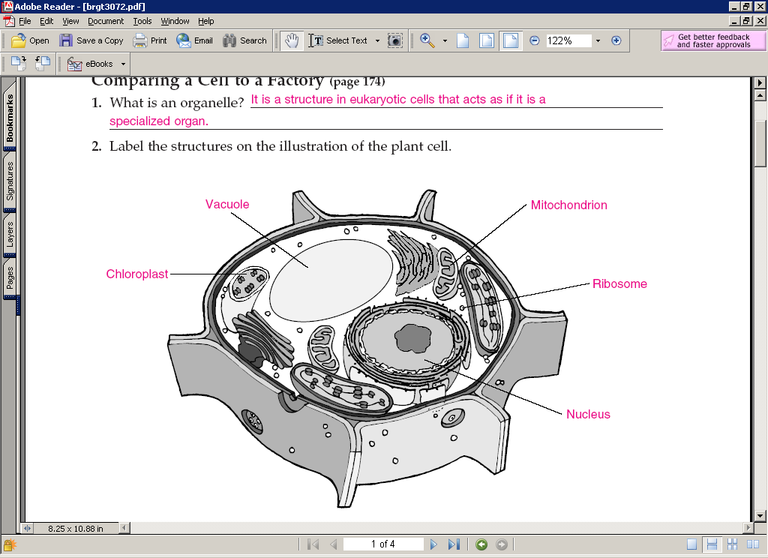

Identify the labeled structures and their function using the text book pages 206-7.