Identify the labeled structures and their function using the text book pages 206-7.

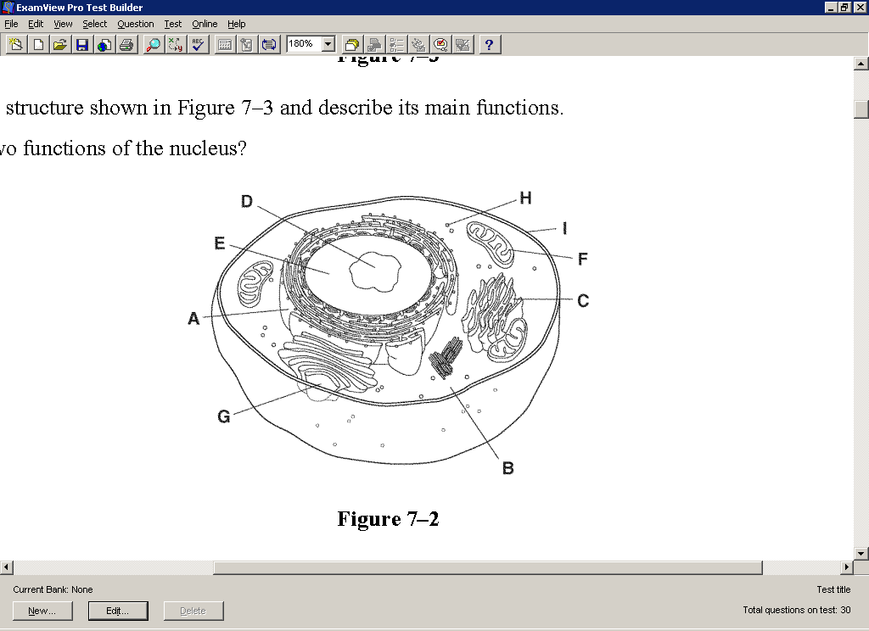

**A**

**B**

**C**

**D**

**E**

**F**

**G**

**H**

**I**

**J**